TASK 1- GIT

### What is Git?

Git is a free, open-source, and distributed version control system designed to manage and track changes in source code efficiently. It allows multiple developers to collaborate on a project, maintain a history of code changes, and revert to earlier versions if needed. Git is lightweight, fast, and reliable, making it an industry-standard tool for software development.

### Key Features of Git

1. Distributed version control: Every developer has a full copy of the repository, including the entire history of changes, allowing offline work and robust collaboration.

2. Branching and merging: Git makes it easy to create, manage, and merge branches, enabling developers to work on features or fixes in isolation.

3. History tracking: Git records every change in the codebase, providing a detailed history of modifications for debugging and accountability.

4. Collaboration: Multiple developers can work on the same project simultaneously without overwriting each other's work.

5. Lightweight and fast: Git is designed to perform operations like commits, branching, and merging quickly and efficiently.

### Uses of Git

1. Version control: Git tracks changes to files over time, allowing developers to roll back to previous states or analyze the evolution of a project.

2. Collaboration: Git enables multiple developers to work on the same codebase while managing conflicts and ensuring smooth integration.

3. Code integrity and backup: Git repositories provide a backup of the entire project and its history, ensuring no data is lost.

4. Feature development: Developers can create isolated branches to experiment or develop features without affecting the main codebase.

5. Continuous integration and delivery (CI/CD): Git integrates seamlessly with CI/CD tools like Jenkins and GitHub Actions to automate testing and deployment.

6. Auditing and debugging: Git’s detailed commit history helps in identifying when and where bugs or issues were introduced.

### Why Use Git?

- Enables efficient teamwork and collaboration.

- Provides a clear history of all changes in the project.

- Helps manage large-scale projects with multiple contributors.

- Simplifies code review and approval processes.

- Supports integration with popular platforms like GitHub, GitLab, and Bitbucket.

CONFIRMATION

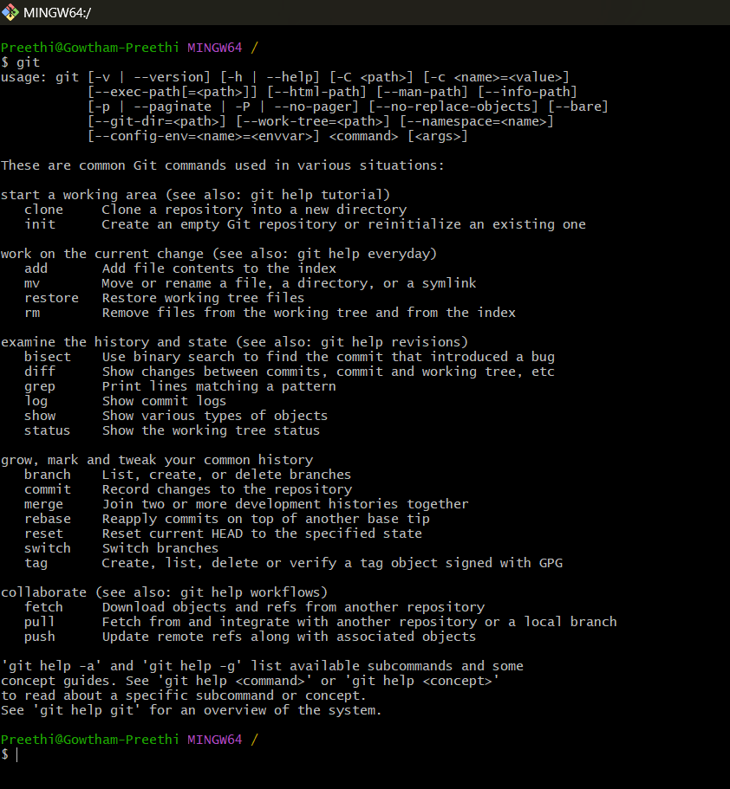

CREATING FILE AND FOLDER

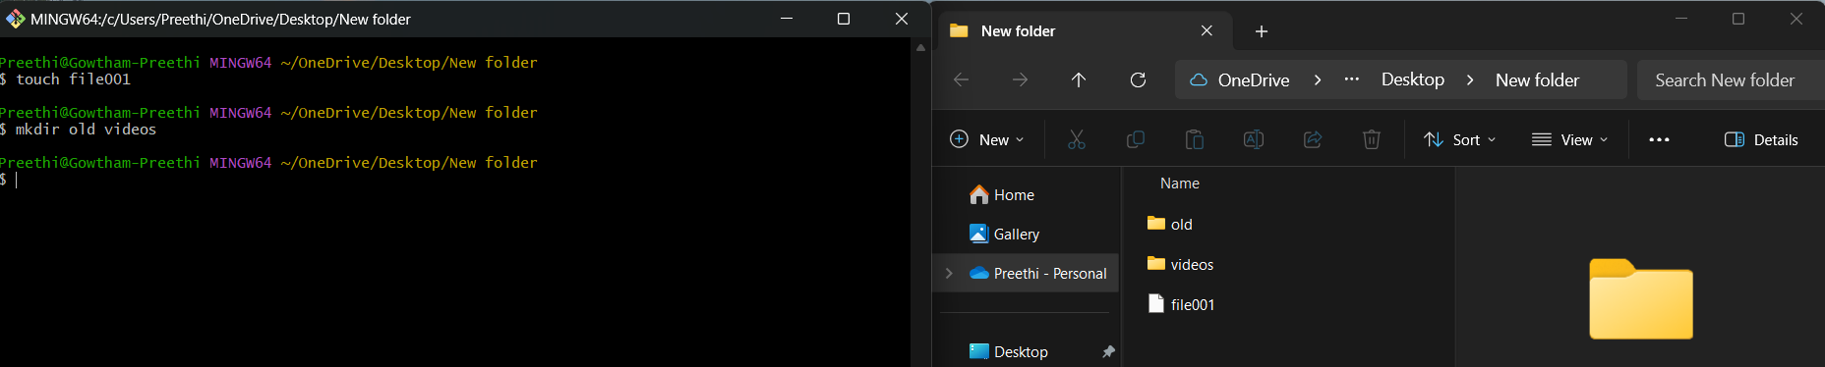

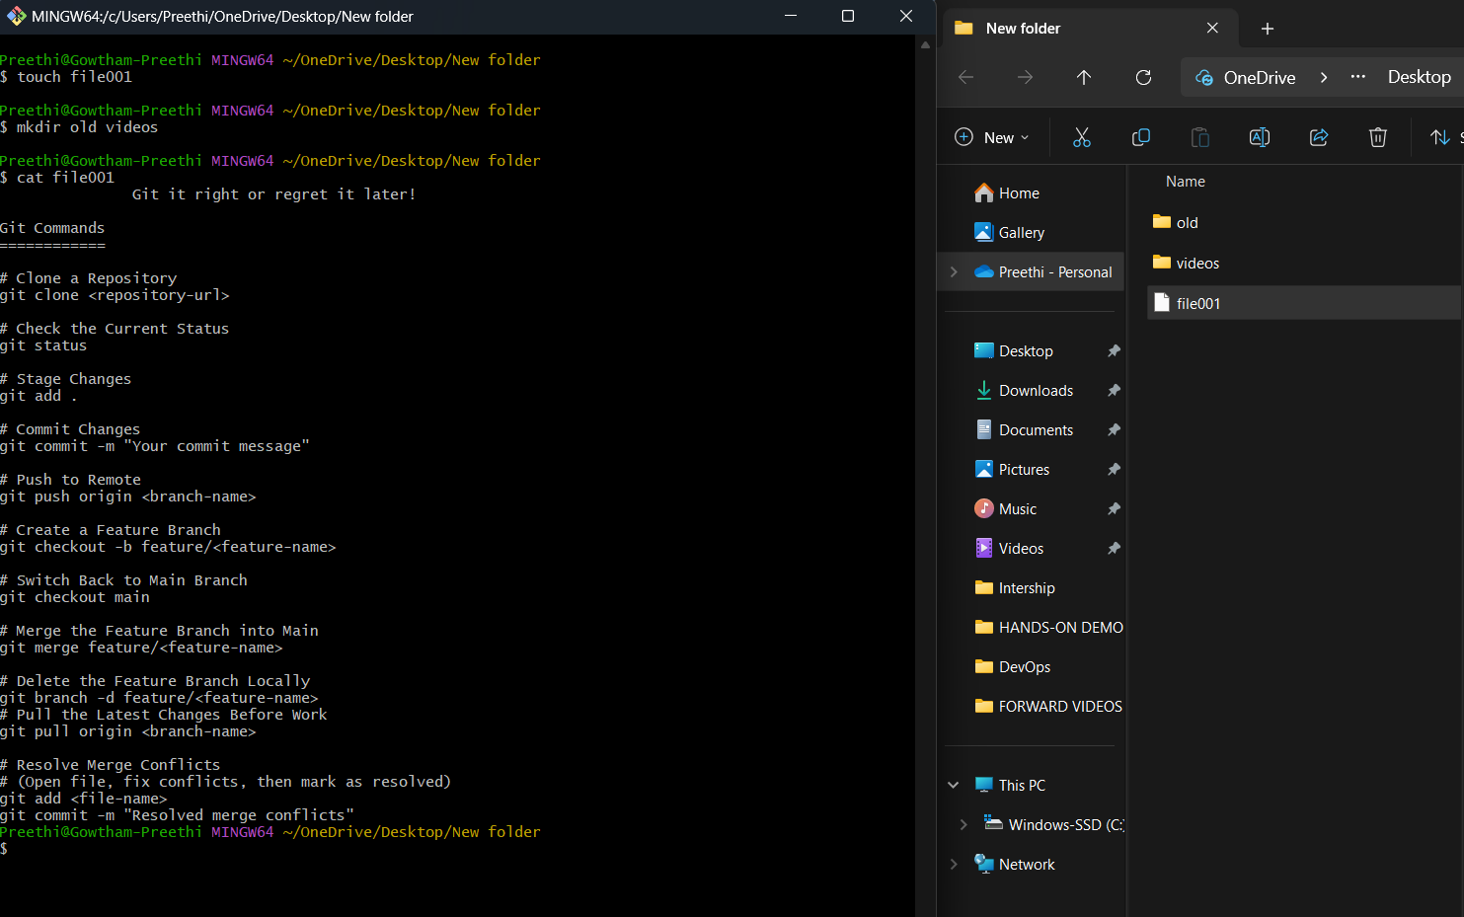

REMOVING FOLDER

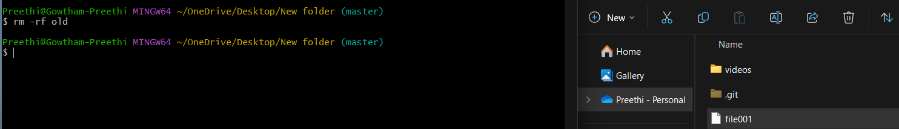

LISTING OUT ALL FILES

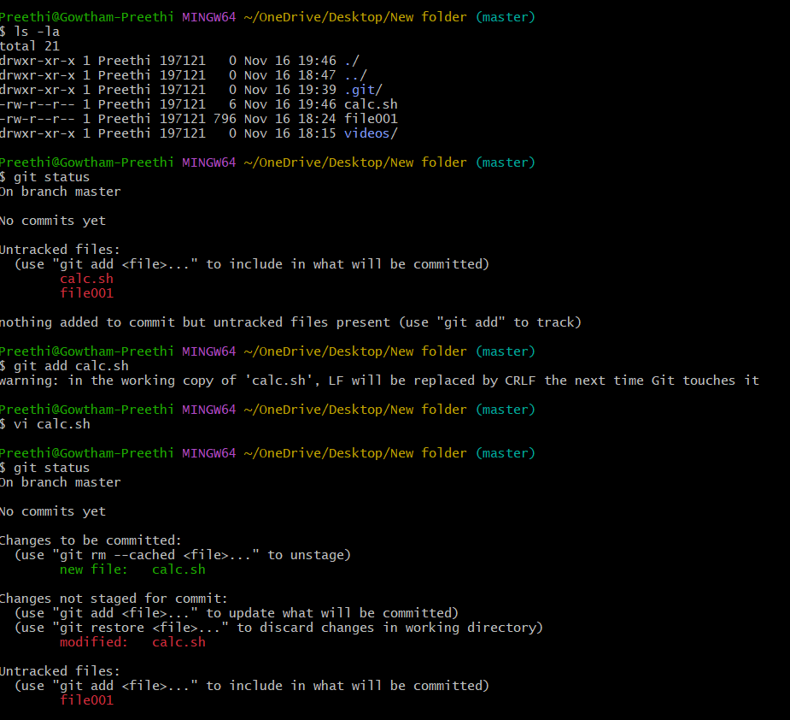

CONFIGURATION

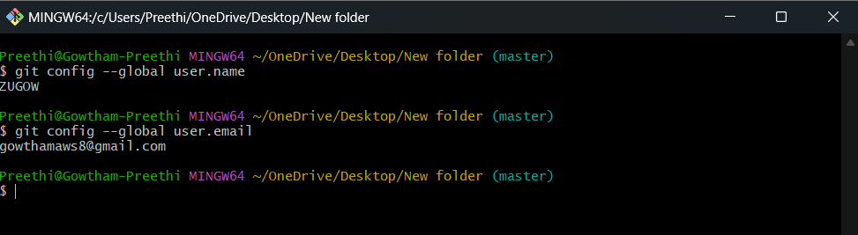



BRANCH CREATION

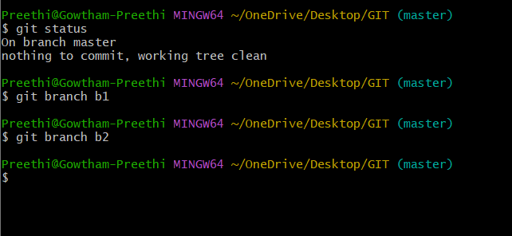

ADD & COMMIT

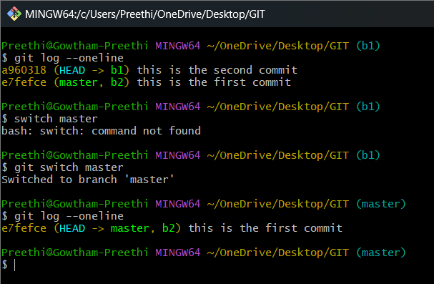

FIRST PUSH TO GITHUB

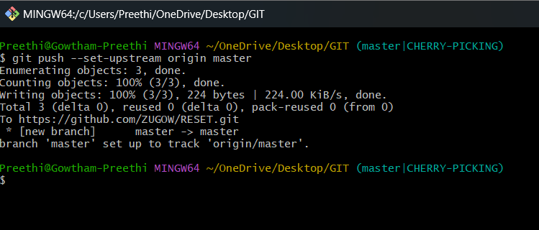

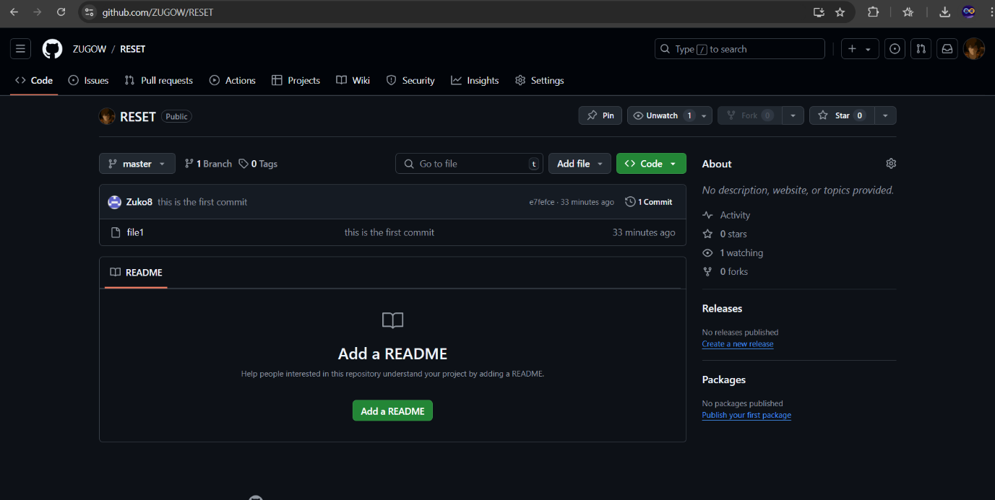

CHERRY-PICK DONE

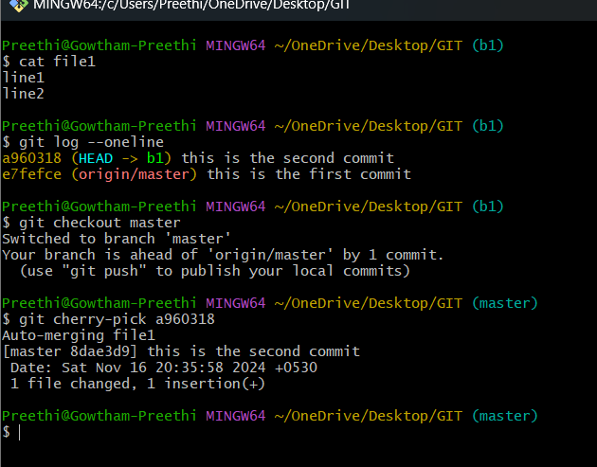

TRYING TO PUSH B1 &B2

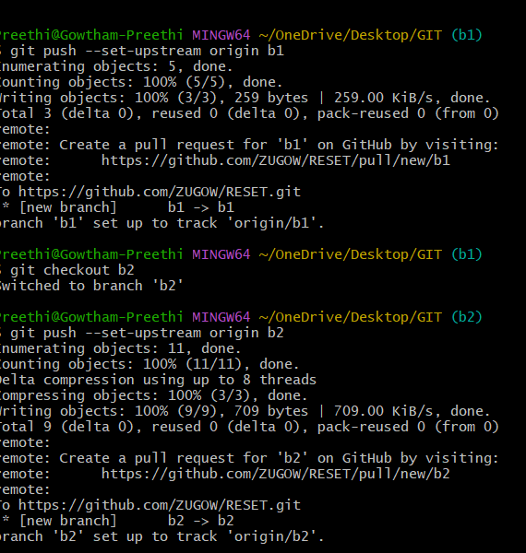

PUSHED B1 & B2

